Madison Kessler
Intermediate Composition
Professor McLaughlin
April 16, 2020
Final Reflection
I have always reflected on who I was as a writer. Analyzing the pieces I enjoy writing which then leads me to wonder why I wrote them first place. Personally, I love to write poetry since it’s my own way of expressing my feelings on perspective. For some reason I’ve always been obsessed with getting a different perspective and knowing how other people think and why they think the way they do. With this being said, I’ve always tried to keep an open mind in my poetry; to not manipulate the reader. In my mind, I genuinely didn’t think there was much more to learn about writing.
My classmates and I were introduced to analyzing articles. I wasn’t sure at first as to why we were supposed to do so, but I didn’t seem to mind since I found almost all of the articles, we ended up reading over the semester, to be quite interesting. The one article that started the semester was “No one could see the colour blue until modern times,” which was written by Kevin Loria. As I’ve already discussed in my last blog post, I loved this article since blue is my favorite color and I couldn’t imagine the world without its existence. One specific quote that caught my eye was “If you see something yet can’t see it, does it exist?” I find this quote to be quite contradicting to some but since I love getting a new perspective, I kept this quote in mind the whole semester.
Our first project that we were assigned was a profile. We were to write a profile about an individual or an organization. I had a hard time figuring out what I wanted to write about because I always want my papers to be a reflective of who I am and what I like. We did an activity in class over pointing out our values in life. For me, my education is one of the things I value. Since I’m studying business and majoring in Marketing, I realized I wanted to write about a business. After some time, I decided to write about Seth Berkowitz, the creator of Insomnia Cookies. I wasn’t sure if I wanted to write about Seth Berkowitz as a person or discuss the process of how the company came to be. I thought it was a great piece to motivate college students into starting a side hustle. Almost every class, we had some time to discuss any suggestions or questions with our classmates. I really enjoyed doing this activity because I was able to get some input on how others would go about my piece and how they would organize it. I came to the conclusion of introducing Berkowitz and how he started the company into what it is now, along with what they offer. Unfortunately, I didn’t find my piece to be worth publishing so I decided to not do so. I had wanted to reach out to Berkowitz and gather some quotes to put in my piece, but he had never contacted me back. I also wanted to go downtown and take pictures of the Insomnia Cookies located in Clifton, but I don’t live on campus and I didn’t really have the time to do so since we were starting on a whole other project.


One of the most important terms I learned in class was “discourse community.” Before entering this class, I had never heard of the term or what it meant. By basic definition, it’s a group of people who share a common interest. I originally learned this term from another article, “Discourse Community,” which was published by the CCC. Another thing I found interesting, and quite obvious, is that each discourse community shares its own language, as a way to discuss that interest they share. As an example, being a Marketing major means that I am in a discourse community with hundreds of other UC students who share the same interest. Anyone that is outside of this discourse community may not understand the language we use such as “data warehousing” or “data mining.”
At the end of revising and potentially publishing our pieces, we started our photo caption lists. As a class, we collectively came up with four different interests that we thought were important to discuss. The interests we came up with was entertainment, mental health, financing, and social media. My group, which consisted of Cj, Abby, and myself, wanted to focus on entertainment. We wanted to use the photo caption for ourselves, so we talked about how much of a struggle it can be to find things to do in Cincinnati.


Specifically, we wanted to talk about affordable places or things to do for college students in Cincinnati, or pretty much anyone that lives or visits Cincy. We could only come up with 9 places and we didn’t really want to add another since 10 is a common number to do for photo caption lists so we wanted our readers to wonder “why nine?” Fortunately, our group was able to publish our revised photo caption list to The Activist. I think we worked with each other really well. To communicate outside of class, we started a group chat over text. If anyone of us had questions or comments, we were pretty quick to respond and give feedback.
The course transitioned into focusing on well known term, “genre.” My professor had asked the class what genre was defined as, and none of us actually knew. It’s one of those words that you understand the concept of, but you’re not sure how to clearly define it. “Genre Awareness for the Novice Academic Student: An Ongoing Quest” and “Genre in the Wild” were two articles we were assigned to analyze about genre. The first article went more into depth about how to define one genre from the next. There was a list of questions to ask oneself when writing about a genre or reading a genre in Table 2. Some of the questions were, “What are you supposed to DO as a writer when completing this task? Are you asked to make an argument? To inform? To describe or list?” This question caught my eye because, as I’ve discussed previously, I want to have a purpose in my writings for the reader to reflect on. The other article we read clearly defines the term “genre” and what guidelines have been followed for each genre. “Genre is a word we use when we want to classify things, to note similarities and differences between kinds of writing” is the definition of the term. I also acknowledged that there is a fine difference between the guidelines of a horror film versus a comedy. Horror novels contain blood, murder, spirits, and monsters while a comedy will contain jokes, different kinds of humor, and relatable situations that make us laugh. These said guidelines help define the difference of each individual genre.
At this point, our midterm reflective check-in was due. This paper had to contain pretty much everything we learned and completed from the past 7-8 weeks. We also had to discuss the process of each assignment and who were as writers compared to that time. I found this assignment to be easy since I remembered everything we learned in class and the thought process I had through half of the semester. I organized my paper by time, so I started with who I was as a writer before the course, the first discussion, into the first assignment, etc. I seemed to connect everything I learned into who I was as a writer halfway through the semester. The order that my paper was in was just the way I wanted it to be, since I going to round everything up at the end of my paper, which I did.
After learning these two terms of “discourse community” and “genre,” I’ve come to notice that these relate to my major. Since I have previously discussed how discourse community relates to my major in Marketing. I want to reflect on how genre can relate to my major. Genre is a word used “when we want to classify things.” My major takes a lot of requirements in order for me to graduate with my bachelors in the year 2022. I have to take two math courses, many business pre-rec classes, and different ranges of marketing classes. These are the guidelines that define my bachelor’s degree in marketing.
In mid-March, a pandemic that had started in the country of China had finally reached Cincinnati, and we were told that our classes were to be shifted and completed online. We were not allowed to learn face to face or get that personal interaction for our professors or our peers. For me, it was a hard transition, and it still is. I didn’t expect COVID-19 to turn into what it is now, which is very scary to me. I know it has affected so many students lives since I have classmates and friends that have full-time jobs, kids, or other outside activities that they are responsible for taking care of. Unfortunately, I was let go from my job as I was about to become a Sales Manager at the store I have been working at for 2 years. Since this happened, I have no source of income. I also personally struggle with anxiety and OCD and being isolated in a house doesn’t help whatsoever. I have to constantly keep myself distracted, which I can easily do when I go to school, work, or even hang out with my friends. I know many students have it way worse than me, and I really hope that they are doing well and taking care of themselves.
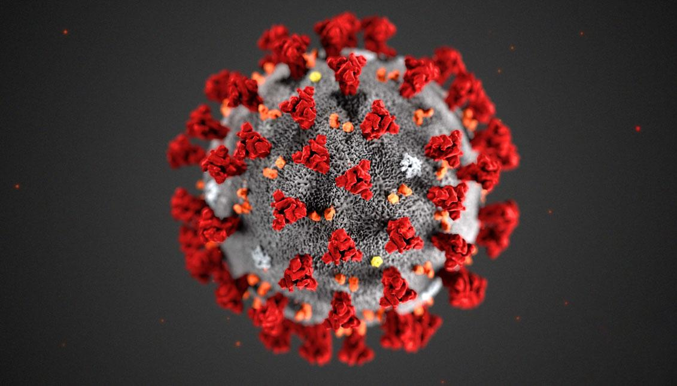

Ever since this pandemic has reached the United States, I have realized that there are terms that correlate with the crisis that is taking place. “Social distancing” is a huge new term for many. If we have to go out of the house to get groceries, go to an essential workplace, or take care of someone, we must always stay 6 feet apart from everyone. “Six feet apart” and “quarantine” are other terms that everyone has been using in the past month. This is a great example of a discourse community. These terms are only understood by those that are going through this pandemic, which is everyone in the world. We are all one discourse community going through isolation together.
Sadly, the very last assignment that we had to do was to reflect on all of the articles we were given over the course of the semester. This took me some time to get done since there were eight readings I had to go back to and fully remember what each one discussed and what I learned from them. I found the assignment to be easy since I had something to say about each individual article. These articles all had to do with discourse community, genre, and perspective. My favorite articles was, of course, “No one could see the colour blue until modern times” and “Mother Tongue.” I’ve already discussed why I loved the first article, so now I want to provide my feedback to the last article we had to read this semester. This article was about the perspective of language and how different people expect English to sound. The most important and loveliest sentence that I noticed in this article was said by the writer herself, Amy Tan. “I wanted to capture what language ability tests can never reveal: her intent, her passion, her imagery, the rhythms of her speech and the nature of her thoughts.” When writing a paper, there should be no said guideline, it is what you think should be placed in that said piece of writing. That is what my professor has been teaching me this whole semester. She taught me to express myself and to envision my own way of writing, rather than going by a rubric made up from some biased English professor.
As a writer, I am now more expressive than I have ever been before. This semester has taught me about being open to other perspectives and noticing the difference between them. This is something that I have always strived to learn in life. I’m no longer worried about following what someone else wants in my writings, but what I want in my writings. I take this lesson with me to finish up the last two years of my college career and for the rest of my life. I now acknowledge myself as a true writer.

Works Cited
- https://www.businessinsider.com.au/what-is-blue-and-how-do-we-see-color-2015-2
- https://wordpress.com/view/madisonenglish.school.blog
- https://secure.ncte.org/library/NCTEFiles/Resources/Journals/CCC/0641-sep2012/CCC0641PosterDiscourse.pdf
- https://openenglishatslcc.pressbooks.com/chapter/genre-in-the-wild-understanding-genre-within-rhetorical-ecosystems/
- http://theessayexperiencefall2013.qwriting.qc.cuny.edu/files/2013/09/Mother-Tongue-by-Amy-Tan.pdf
- https://s3.amazonaws.com/secretsaucefiles/photos/images/000/212/740/large/insomnia_cookies.png?1535077148
- https://travel.home.sndimg.com/content/dam/images/travel/stock/2018/5/16/iStock_Cincinnati-Skyline_641449108_xl.jpg.rend.hgtvcom.1280.853.suffix/1526499909887.jpeg
- https://aldianews.com/sites/default/files/styles/article_image/public/articles/1131-covid-19.jpg?itok=U_eOhaUp

