
10 Affordable Places to Visit in Cincinnati

Main Event is a family friendly place that has pretty much everything from its own restaurant, bowling, an arcade, mini golfing, to rock climbing! Main Event is located in West Chester Township, about 20 minutes on the outskirts of Cincinnati. Main Event is mainly known for their bowling in the city. What makes its bowling stand out from other bowling allies is its glow in the dark! They have great music and view music videos and sports games on multiple HD screens in front of each ally. Also, while you’re playing, you can order food and drinks and get them waited to you. Prices to bowl each hour vary on the days and time, but on average range from $22/hr to $36/hr. It’s a great place to be with friends and family for some competitive bowling!



The American Sign Museum is one of the coolest museums we have here in Cincinnati. Home to hundreds of elaborate and beautiful neon signs from across the country, this museum holds unique style that many museums can’t compare to. The American Sign museum was created by Tom Swormstedt, who was the editor and publisher for Sign of the Times magazine before founding the museum. His collection dates to the 1800s up through the 1970’s. The museum is open on Wednesday through Saturday 10:00 am to 4:00pm and Sunday at 12:00pm to 4:00pm. Note that it is closed on Mondays and Tuesdays. For pricing, it ranges from $10 - $15 dollars depending on your age, and kids 12 & under get in free with each paid adult.

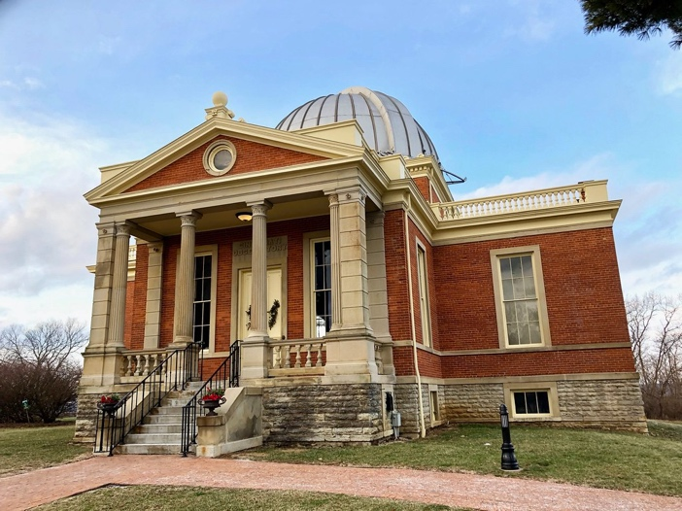
Ever wanted to see a panoramic view of Cincinnati? We recommend the Carew Tower Observation Deck, located in downtown Cincinnati. On the 49th floor in the highest elevated building in the city, you can see every building and hill in the city, even a view of Northern Kentucky! Carew Tower holds 25 shops, restaurants, and other amenities for your entertainment wants and needs. It’s $6 ages 12 and up, $3 ages 6-11, and free for ages 5 and under. One tip to keep in mind when visiting the tower is to bring cash, specifically small bills, since they don’t take debit/credit cards.


Starting with one of the best places to go in Cincinnati that is light on the wallet would be Hyde park. Beyond its great atmosphere and amazing shops that fill the area it is also home to Cincinnati’s own observatory. This is amazing event is only 5 dollars a person and a great way to send some time and learn a few things. Cincinnati’s Observatory has the Mitchel scope the oldest still working telescope in the hemisphere. So just remember when you’re have a great time looking through into the starts exploring the unknown that it’s not a bird or a plane it’s probably aliens just flying around in their UFO having a good ole time.

Bringing your assets right back to Hyde park we have breakout games Cincinnati’s #1 escape room. This complex puzzle and game is fun for everyone. With there being different levels of difficulty and bringing everyone in together for a good challenging time. For anyone that doesn’t know what an escape room is locking a group of people in a room with a list of objectives and clues to see if they can get out in 1 hour. This is a great activity to do with your friends or family or both. The cost varies by how many people you have in your group and the escape game you’re going to be playing. But it’s worth the whole hour to experience the fun of being locking in a room with all your friends….. unless you’re not into those kind of things.

3Quest Challenge

3Quest Challenge is a digital adventure game that takes you around the city to complete 3 quests using an app on your smartphone. You'll start out at a home base location, then the app will lead you on 3 quests around the city(always within walking distance) Each quest has 3 checkpoints. At each checkpoint, you'll answer a question to collect a clue, and then perform a challenge. For each question you answer correctly, you score a point. After you've completed the quests, you'll come back to your Home Base to solve your final puzzle using the clues you've collected, and get even more points by solving the puzzle correctly so try and be accurate and not all whilly nilly.


The Krohn’s Conservatory Showcases more than 3,500 plant species from around the world including desert plants and carnivorous plants. Some of their year round plants include bonzai trees and cacti. Annually, the Krohn’s conservatory hosts a popular butterfly show available at the end of March- June. Admission is 7 Dollars per person.


Admission: Ranges per season around 25 Dollars
Home to Fiona the Hippo and hundreds of other animals, our Cincinnati Zoo ranges from large cats all the way to reptiles. The zoo offers more than just animals, take a walk through their botanical garden and other tours!


Admission: Free! Consider a Donation
The Contemporary Arts Center has many different exhibitions in and out every few months. See modern art as you explore through its spacious rooms and find their interactive pieces throughout.

